



TASK-1: Titanic Survival Classification

Date | 20th April 2026
Name | MUHAMMAD ABDULLAH
work assigned by | Arch technologies
Email | Ma12345n12@gmail.com
number | 03353990494

CODE:
import pandas as pd
import numpy as np
import matplotlib.pyplot as plt
import seaborn as sns
from sklearn.model_selection import train_test_split
from sklearn.linear_model import LogisticRegression
from sklearn.metrics import accuracy_score, classification_report
# Load dataset
df = pd.read_csv("train.csv")
# -------------------------
# Data Cleaning
# -------------------------
df['Age'].fillna(df['Age'].mean(), inplace=True)
df['Embarked'].fillna(df['Embarked'].mode()[0], inplace=True)
df.drop(['Cabin', 'Name', 'Ticket', 'PassengerId'], axis=1, inplace=True)
# Convert categorical to numeric
df['Sex'] = df['Sex'].map({'male': 0, 'female': 1})
df = pd.get_dummies(df, columns=['Embarked'], drop_first=True)
# -------------------------
# Features & Target
# -------------------------
X = df.drop('Survived', axis=1)
y = df['Survived']
# -------------------------
# Train-Test Split
# -------------------------
X_train, X_test, y_train, y_test = train_test_split(X, y, test_size=0.2, random_state=42)
# -------------------------
# Model Training
# -------------------------
model = LogisticRegression(max_iter=1000)
model.fit(X_train, y_train)
# -------------------------
# Predictions
# -------------------------
y_pred = model.predict(X_test)
# -------------------------
# Evaluation
# -------------------------
print("Accuracy:", accuracy_score(y_test, y_pred))
print("\nClassification Report:\n", classification_report(y_test, y_pred))
# -------------------------
# Visualization
# -------------------------
sns.countplot(x='Survived', data=df)
plt.title("Survival Count")
plt.show()

CODE EXPLANATION:

1. Library Imports
This section imports all necessary libraries for data manipulation, numerical operations, plotting, machine learning model selection, and evaluation.

2. Data Loading
The train.csv dataset is loaded into a pandas DataFrame. This dataset contains information about passengers on the Titanic, including whether they survived.

3. Data Cleaning and Preprocessing
This crucial step prepares the raw data for machine learning. It involves handling missing values, dropping irrelevant columns, and converting categorical features into a numerical format that the model can understand.

4. Feature and Target Separation
The dataset is split into features (X), which are the input variables used for prediction, and the target variable (y), which is what we want to predict (survival).

X = df.drop('Survived', axis=1)
y = df['Survived']

5. Train-Test Split
The data is divided into training and testing sets. The model learns from the training data and is then evaluated on the unseen testing data to assess its generalization performance.

X_train, X_test, y_train, y_test = train_test_split(X, y, test_size=0.2, random_state=42)

6. Model Training
A Logistic Regression model is initialized and trained using the training features (X_train) and their corresponding target values (y_train). max_iter=1000 is set to ensure convergence.

7. Predictions
The trained model makes predictions on the test set (X_test).

8. Model Evaluation
The model's performance is evaluated using accuracy_score and a classification_report, which provides precision, recall, and f1-score for each class (survived/not survived).

9. Visualization
A count plot is generated to visualize the distribution of Survived outcomes in the original dataset, showing how many passengers survived versus how many did not.

VISUAL Screenshot:
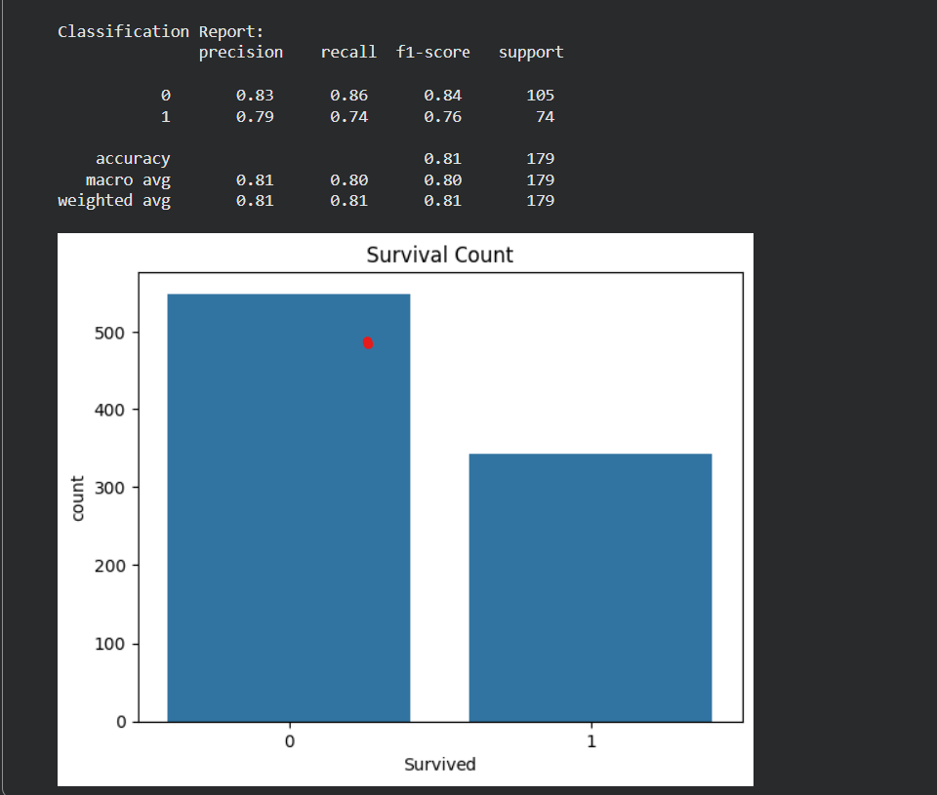

TASK-2: Stock Price Prediction

CODE:

# Import libraries

import pandas as pd

import matplotlib.pyplot as plt

from sklearn.model_selection import train_test_split

from sklearn.linear_model import LinearRegression

from sklearn.metrics import mean_squared_error, r2_score

# Load dataset

df = pd.read_csv("AMZN_stock_data.csv")

# Show data

print(df.head())

# -------------------------

# Select features

# -------------------------

X = df[['Open', 'High', 'Low', 'Volume']]

y = df['Close']

# -------------------------

# Split data

# -------------------------

X_train, X_test, y_train, y_test = train_test_split(X, y, test_size=0.2)

# -------------------------

# Train model

# -------------------------

model = LinearRegression()

model.fit(X_train, y_train)

# -------------------------

# Predict

# -------------------------

predictions = model.predict(X_test)

# -------------------------

# Evaluate

# -------------------------

print("MSE:", mean_squared_error(y_test, predictions))

print("R2 Score:", r2_score(y_test, predictions))

# -------------------------

# Plot

# -------------------------

plt.plot(y_test.values, label="Actual")

plt.plot(predictions, label="Predicted")

plt.legend()

plt.show()

CODE EXPLANATION:
- Import Libraries: It imports necessary libraries like pandas for data manipulation, matplotlib.pyplot for plotting, and sklearn modules for model selection (train_test_split), linear regression (LinearRegression), and evaluation metrics (mean_squared_error, r2_score).
- Load Dataset: The code loads the AMZN_stock_data.csv file into a pandas DataFrame named df.
- Show Data: df.head() is used to display the first few rows of the loaded DataFrame, giving a quick look at the data structure.
- Select Features: It defines the features (X) for the model as 'Open', 'High', 'Low', and 'Volume' columns from the DataFrame. The target variable (y) is set to the 'Close' column.
- Split Data: The data is split into training and testing sets using train_test_split. 80% of the data is used for training the model, and 20% is reserved for testing its performance.
- Train Model: A LinearRegression model is initialized and then trained (model.fit) using the training data (X_train, y_train).
- Predict: The trained model makes predictions (model.predict) on the test features (X_test).
- Evaluate: The model's performance is evaluated using two metrics:
  - Mean Squared Error (MSE): Measures the average squared difference between the actual and predicted values. Lower MSE indicates better accuracy.
  - R2 Score: Represents the proportion of the variance in the dependent variable that is predictable from the independent variables. A score closer to 1 indicates a better fit.
- Plot: Finally, the actual closing prices (y_test.values) and the predicted closing prices (predictions) are plotted on a graph to visually compare how well the model's predictions align with the actual values.

VISUAL SCREENSHOT:
